|  |
| --- |
| Journal OF COMMON NONSENSE Community Mod at github.com/PublishOrPerish/mod |

**A Peer Review Expansion**

**for The Publish or Perish Game**

jbji

University of Harder Publish and Fair Game

|  |  |  |
| --- | --- | --- |
| Expansion Info |  | ABSTRACT |
| 4+ Thousand Compatible Logo Royalty-Free Images, Stock Photos & Pictures |  Shutterstock  extra 20-50min  significantly modifies publication process |  | Why it’s always THAT player winning the game? He must have found some sort of optimal strategy! In this expansion, you are now capable of giving explicit Peer Reviews to your colleagues’ work to stop them from ALWAYS winning the game! Let there be reviewer 2! The introduced review uncertainty makes the original game even more chaotic, adding another layer of game in-depth. |

**Introduction**

Distribute a Review Rule Summary to each player to review. This expansion includes one extra Action Card (a), an extra type of Peer Review Cards (b), and one preprint mark (c). You need to create draw piles for Peer Review Cards. There are three types of Peer Review Cards: Rating Cards, Decision Cards, Rebuttal Cards, see Figure 1.

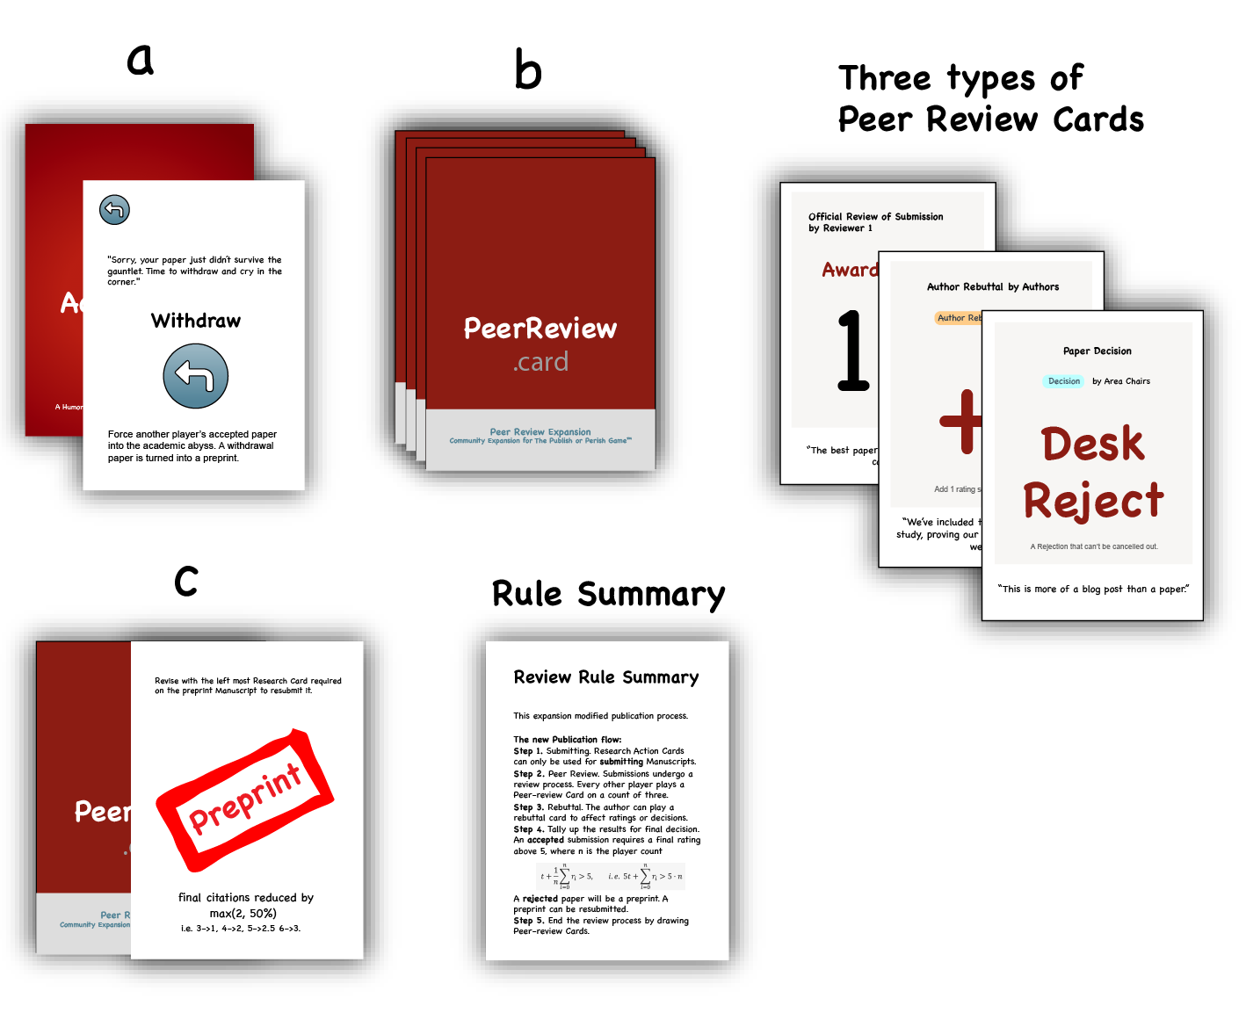

Figure 1. New Cards introduced by this expansion

**Method**

Setup the review expansion by dealing each player three Peer Review Cards to be held in secret. One can hold exactly three Peer Review Cards.

**The New Peer Review Publication Flow.** This expansion modifies Bai (2025)’s publication step & ending condition.  
(1) Play all the required Action Cards as shown by icons on a Manuscript Card you intend to **submit** it.

(2) **Peer Review.** Other researchers play Peer Review Cards, one for each, to give **ratings or decisions** along with reviews on a count of three. One can discard Rebuttal Cards and redraw if they can’t give a rating or decision. Contradictory Decision Cards can cancel out each other, except “Desk Reject”. Jump to Step (5) if a decision is already made.

(3) **Rebuttal.** Rebuttal by playing Rebuttal Cards to alter results.

(4) Work out **final decision** to by averaging ratings then add rebuttal if there is no Decision Card. Manuscripts will be accepted if the final rating is above five. See eq.(1), where is player count and is the rebuttal bonus,

A rejected paper will be a **preprint**, each paper marked as preprint loses 2 points of citation. Put a preprint mark next to a preprint.

(5) Announce and celebrate accepted paper.

(6) Draw Peer Review Card to replenish hands. If the Peer Review Card draw pile is depleted, randomly take half of the discard pile to form a new draw pile.

**Preprint.** A preprint has reduced citation by , i.e. 3->1, 4->2, 5->2.5 6->3.

**Revise & resubmit.** A preprint can be resubmitted after revising with the left most Research Card required on a preprint Manuscript.

**Withdraw.** This happens when “withdraw” Action Card is used on an accepted paper. A paper withdrawal returns to preprint state.

**Results**

When a player gets their fourth Manuscript accepted, or has arbitrary seven Manuscripts faced up, all

others will have one more turn before the defense.

**Conclusion**

Finally! They can no longer always win.

**References**

Bai, M. H. (2025). The Publish or Perish Game: A Humorous Party Game About Academic Publishing. Journal of Common Nonsense.

**Appendix A**

**This section provides additional information and**

**clarifications on how the cards work. It is NOT**

**necessary to read this section before playing.**

**Action Card – Withdraw**

These cards are used to withdraw other player’s manuscript (see Figure 2). A withdrawal Manuscript is turned into a preprint.

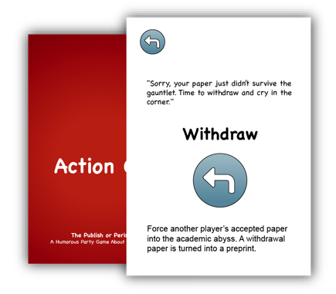

Figure 2. Withdraw Card

**Peer Review Cards**

There are three categories of Peer Review Cards: Rating Cards, Decision Cards, Rebuttal Cards.

* **Rating Cards**: They aim to simulate the reviewer’s rating process by allowing player give scores by playing cards (see Figure 3).

Figure 3. Rating Cards

* **Decision Cards**: They aim to simulate Area Chair decisions on a paper (see Figure 4). These cards have a higher priority than Rating Cards.

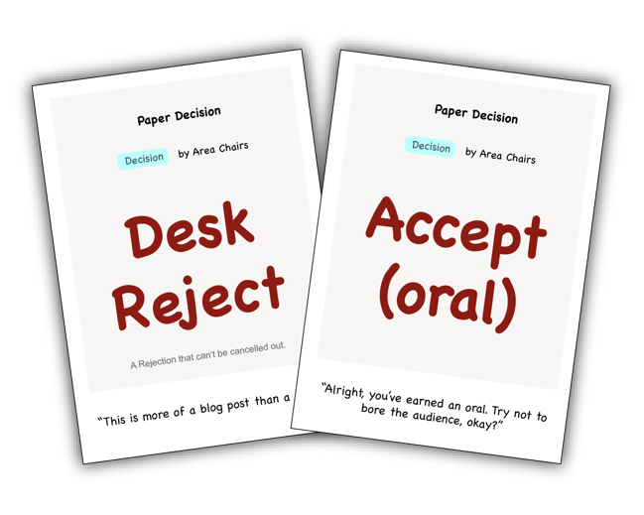

Figure 4. Decision Cards

* **Rebuttal Cards**: Authors can play these cards in the rebuttal stage to alter scores (see Figure 5).

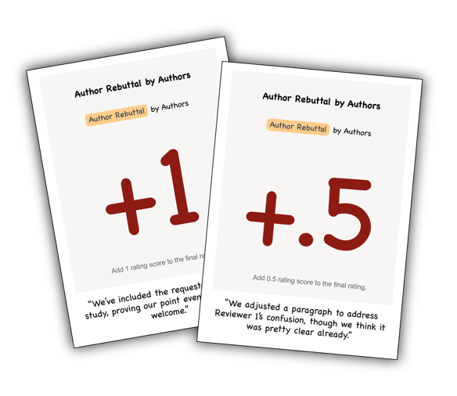

Figure 5. Rebuttal Cards